Split 1

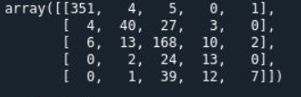

Split 2

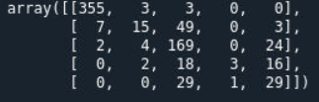

Split 3

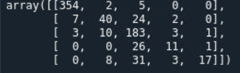

Split 4

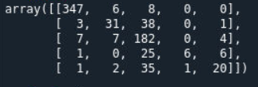

Split 5

